Screen Shots VBA of Wall street

2016



Figure 2016 Screenshot Excel Stock Data

2015



Figure 2015 Screenshot Excel Stock Data

2014



Figure 2014 Screenshot Excel Stock Data

To run the Macro I installed a button on 2014 sheet

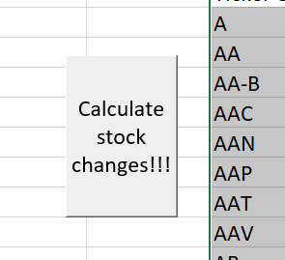

Figure Screenshot of button launching the macro

Once the button was pressed the Macro ran through all the sheets yielding the results presented in the initial screenshots.